Question 1

First I have created a playbook play.yaml

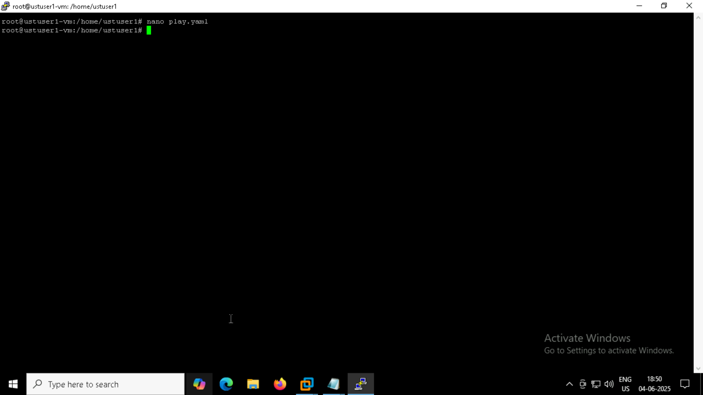

Next I wrote palybook based on the question

